Chapter 1: Introduction
Wealth-Nexus is an enterprise-grade Mutual Fund wealth management and financial advisory platform designed to help investors and distributors manage investment portfolios with clarity and intelligence. It automates mutual fund data ingestion from public NAV feeds and user transaction uploads to reconstruct portfolios and compute real returns, eliminating manual tracking and spreadsheet calculations. The platform provides real-time performance metrics including XIRR, CAGR, and profit/loss, and offers actionable insights such as goal-tracking, risk scoring, and cost-savings analysis between direct and regular plans. Authentication is handled through secure JWT-based login, ensuring advisors see only the data they are authorized to. Wealth-Nexus focuses on transparency, optimization, and trust in personal finance management, aligning with modern investment practices and providing a scalable solution for financial advisory in the Indian mutual fund market.
1.1 Brief Overview of the Work
Wealth-Nexus is an intelligent wealth management and portfolio analytics platform designed to address the challenges faced by investors in tracking, analyzing, and optimizing their mutual fund investments. Traditional investment tracking methods often rely on fragmented systems or manual calculations, which can lead to inaccuracies, inefficiencies, and lack of actionable insights. Wealth-Nexus transforms this process into a streamlined, data-driven, and automated workflow.
The core functionality of the platform revolves around the aggregation and processing of investment data. Users can upload their transaction history or fetch investment records, after which the system reconstructs their complete portfolio. Advanced financial computations, such as XIRR (Extended Internal Rate of Return) and CAGR (Compound Annual Growth Rate), are calculated to provide accurate performance evaluation. Additionally, the system integrates automated NAV (Net Asset Value) updates to ensure real-time portfolio valuation.
A key feature of Wealth-Nexus is its intelligent analytics and advisory capabilities. The platform enables users to set financial goals and track their progress using predictive projections. Furthermore, real-time alerts and notifications inform users about portfolio performance, goal deviations, and important investment events, helping them stay informed and take timely decisions.
Wealth-Nexus simplifies portfolio management, performance analysis, and financial planning through an integrated and scalable architecture. By combining automation, advanced financial computations, and intuitive visualization, the platform empowers investors to make informed decisions with greater transparency, accuracy, and efficiency.
1.2 Project Objectives
● To implement an automated data ingestion pipeline that fetches daily NAVs from public sources and integrates user CSV transactions to build accurate mutual fund portfolios.
● To develop a robust backend that computes financial metrics such as XIRR, CAGR, and profit/loss for portfolios with multiple cash flows.
● To design and build a secure authentication and authorization mechanism using JWT.
● To create an interactive dashboard that empowers users to visualize portfolio value, asset allocation, goal progress, and risk indicators.
● To enable financial goal setting and tracking features, allowing users to set targets and receive real-time progress updates.
● To implement support for systematic investment operations such as SIP (Systematic Investment Plan), STP (Systematic Transfer Plan), SWP (Systematic Withdrawal Plan), and redemption, enabling users to simulate real-world mutual fund investment behaviors.
● To deliver smart alerts and advisory suggestions based on portfolio performance, drift, and goal deviation.
● To establish comprehensive logging and audit trails for all important system events, data ingestion, and user actions.
● To validate and test system components to ensure reliability, scalability, and accuracy for real-world mutual fund portfolio scenarios.

1.3 Project Scope
● The system focuses on automated portfolio construction and wealth management for mutual fund investors in the Indian market.
● The system is designed for Indian mutual fund market practices, leveraging publicly available NAV data and investor inputs to generate insights.
● It enables goal-oriented financial planning and tracking, allowing users to define and monitor investment goals.
● The platform maintains audit logs of data updates, calculations, and user actions to ensure transparency and accountability.
● The scope excludes direct financial transactions (buy/sell execution) and billing

  - Project Modules
    - Authentication
● Users can securely log in and register using JWT-based authentication.
● Access is restricted to individual investor data only, ensuring privacy and data isolation.
1.4.2 Data Ingestion & Portfolio Reconstruction Module
● The system fetches daily NAV (Net Asset Value) data from public sources and stores it efficiently.
● Users can upload CSV files containing transaction data, which are parsed and processed.
● The platform reconstructs the complete mutual fund portfolio automatically from raw transaction data.
1.4.3 Portfolio Analytics Module
● The system calculates key financial metrics such as XIRR, CAGR, total investment, and profit/loss.
● Handles multiple cash flows across different dates using advanced financial algorithms.
● Provides accurate and real-time portfolio valuation using updated NAV data.
1.4.4 Investment Operations Module (SIP, STP, SWP, Redeem)
● Supports simulation and tracking of real-world mutual fund operations:
- SIP (Systematic Investment Plan) – periodic investments
- STP (Systematic Transfer Plan) – fund-to-fund transfers
- SWP (Systematic Withdrawal Plan) – periodic withdrawals
- Redeem – one-time withdrawal of units
● Enables users to understand investment behavior and cash flow impact.
● Simulates real mutual fund lifecycle operations within the platform.
1.4.5 Goal Tracking & Financial Planning Module
● Users can define financial goals such as retirement, education, or savings targets.
● The system calculates projected future value based on current investments.
● Provides progress tracking and deviation analysis for goal achievement.
1.4.6 Dashboard & Visualization Module
● Provides an interactive dashboard built using charts and graphs.
● Displays portfolio value, asset allocation, returns, and performance trends.
● Enables users to visually analyze their investments in real time.
1.4.7 Alerts & Notification Module
● Generates real-time alerts based on portfolio changes and goal deviations.
● Notifies users about performance changes, unusual movements, or milestones.
● Enhances decision-making through timely insights.

1.5 Basic Requirements
1.5.1 Hardware requirements
- Dev Systems: 8GB RAM, Intel i5 Processor
- Hosting: Vercel and render with 16GB RAM
1.5.2 Software requirements
● Frontend:
➔ React.js – To develop the interactive investor dashboard and client UI. React supports dynamic data binding, state management, and integration with charting libraries for seamless visualization..
● Backend:
➔ Spring Boot (Java) – Provides robust REST APIs, business logic, and financial computation services. Handles tasks like CSV ingestion, portfolio reconstruction, return calculations, and alert generation.
➔ Spring Scheduler & Multi-Threading – Enables asynchronous processing for large CSV files, NAV fetching, and scheduled jobs for real-time data updates.
● Database & Storage:
➔ MongoDB – Stores investor profiles, transaction histories, reconstructed portfolios, NAV records, and audit logs in a flexible document structure, supporting high-volume financial data.
● APIs & Data Integration:
➔ AMFI NAV Public Feed / Free Mutual Fund APIs – Daily mutual fund NAV data are fetched automatically to update valuation metrics.
➔ CSV Upload Interface – Enables investors to import RTA-style transaction data for portfolio building.
● Notifications & Alerts:
➔ WebSockets – Enables real-time push notifications on the dashboard for alerts like portfolio drift, goal deviation, or SIP reminders
Chapter 2: Literature Review
Review 1. Mutual Fund Performance Evaluation and Return Metrics
● Title: Measures of Mutual Fund Performance: Risk, Return, and Risk-Adjusted Performance
● Authors: Francisco Casino, Thomas K. Dasaklis, Constantinos Patsakis (et al.)
● Reference Link:
➔https://www.researchgate.net/publication/378542453_Measures_of_mutual_fund_performance_Risk_return_and_risk_adjusted_performance_persistence_and_forecasting_ability
● Core Findings:
➔ Mutual fund performance evaluation uses multiple quantitative metrics such as risk-adjusted returns, Sharpe ratio and persistence of performance.
➔ Understanding and comparing different measures (e.g., Treynor, Jensen) allows investors to make informed portfolio decisions.
➔ Performance measurement is critical for portfolio construction and benchmarking.
Review 2. XIRR and Return Measurement for Irregular Cash Flows
● Title: Understanding XIRR — A Key Metric for Mutual Fund Performance
● Source: Online financial research on XIRR usage in mutual funds
● Reference Link:
➔ https://www.quantumamc.com/article/understanding-xirr-a-key-metric-for-mutual-fund-performance
● Core Findings:
➔ XIRR (Extended Internal Rate of Return) accounts for irregular cash flows and timing of investments.
➔ XIRR provides a more accurate picture of actual investor returns than simple CAGR, especially for SIP-based mutual fund investments.
➔ It reflects time value of money and performance variations due to timing and magnitude of cash flows.
Review 3. Portfolio Management and Risk-Return Analysis
● Title: Study of Financial Sector & Portfolio Management
● Authors: Saurabh Agarwal, Sarita V. (et al.)
● Reference Link:
➔ https://www.dsims.org.in/assets/files/r-vol/5_Saurabh-Agarwal-Sarita-V.pdf
● Core Findings:
➔ Portfolio management involves balancing risk and return based on investor risk profile.
➔ Effective diversification reduces risk and improves return performance.
➔ Investors should align investment decisions with risk tolerance and financial goals.
Review 4. Role of Performance Evaluation Techniques in Mutual Funds
● Title: Portfolio Management Strategies and Performance of Mutual Fund Managers in India: An Empirical Investigation
● Authors: Dr. Y. Maheswari
● Reference Link:
➔ https://ssrn.com/abstract=5923026
● Core Findings:
➔ Performance evaluation of mutual funds often goes beyond simple return figures; it includes conditional performance models that reduce bias.
➔ Evaluating mutual funds through sophisticated metrics can provide deeper insight into investment efficacy.
➔ These models are relevant for investors comparing performance across different fund categories.
Review 5. Practical Measures for Evaluating Mutual Fund Performance
● Title: 5 Ways to Measure Mutual Fund Performance
● Reference Link:
➔ https://www.adityabirlacapital.com/abc-of-money/5-ways-to-measure-mutual-fund-performance
● Core Findings:
➔ Evaluating mutual fund performance includes multiple indicators such as expense ratio, allocation details, and rolling returns.
➔ Expense ratios and portfolio allocation patterns play a significant role in overall investor outcome.This supports Wealth-Nexus’s feature of multi-metric analytics (including allocation insight and cost impact) for better investment assessment
Chapter 3: System Analysis and Design
3.1 Comparison of Existing Application (INDMoney) with Our Project (WealthNexus)
Key Aspects | IndMoney | WealthNexus
Core Focus | Comprehensive investment tracking & wealth planning | Automated mutual fund portfolio reconstruction and deep analytics
Authentication | Traditional login (email/phone + password / OTP) | JWT-based secure authentication
Role hierarchy | Investor dashboard only | Investor dashboard with advanced analytics and end-to-end portfolio insightst
Product creation authority | Basic returns / dashboards | XIRR, CAGR, Profit/Loss, risk scoring
Supply chain model | Expense observation | Direct vs Regular savings projection and simulated future savings
Product identity | Yes | Yes with projected future value and progress alerts
Product lifecycle tracking | Manual / semi-automated | Fully automated via NAV feeds + CSV import
Businesses onboarding | Basic charts | Advanced visual analytics, alerts, and advisory recommendations

Table 1: Comparison – IndMoneyvs. WealthNexus

  - Project Feasibility Study
3.2.1 Technical Feasibility:
● Wealth-Nexus is built using widely used open-source technologies such as React.js for the frontend and Spring Boot for the backend.
● The selected tech stack supports scalable web-based development with fast rendering, responsive design, and easy integration of analytics and charting libraries.
● Using MongoDB ensures efficient storage and fast retrieval of financial data, enabling real-time portfolio valuation and computation.
● JWT-based authentication ensures secure, tokenized access, preventing unauthorized access while maintaining session integrity.
● Automated NAV fetching and scheduled jobs allow real-time data updates without manual intervention.
3.2.2 Economic Feasibility:
● The system leverages free and open-source components (React, Spring Boot, MongoDB Community Edition, Redis) to minimize development and operational costs.
● No proprietary APIs are required the project uses publicly available mutual fund NAV feeds and simple CSV uploads for transaction data, reducing recurring expenses.
● Hosting can be initially done on free or low-cost cloud services (such as Heroku, Vercel, or MongoDB Atlas free tier), ensuring minimal infrastructure costs during development and testing.
● Developer productivity is increased due to extensive open-source community support, reducing debugging time and cost.
● Low operational cost makes the platform economically viable for student development and potential real-world prototyping.
3.2.3 Operational Feasibility:
● The user interface is designed to be intuitive and straightforward — investors can upload their transaction CSV files and view analytics with minimal training.
● Portfolio reconstruction, return calculation, and goal tracking are automated processes, which reduces manual effort and human error.
● Alerts and notifications are generated automatically based on pre-defined conditions, keeping investors informed without constant monitoring.
● The system fits well into existing investor workflows by allowing CSV import (similar to RTA exports), NAV updates, and interactive dashboards without disrupting current investment record-keeping practices.
● Since the platform uses standard web technologies, it can be accessed from any modern browser without special software installation.
3.3 Project Timeline Chart
Phase | Duration | Dates
Requirement Analysis | 1 week | 01/01/26 – 09/01/26
Frontend Dev | 2 weeks | 11/01/26 – 25/01/26
Database Integration | 1 week | 27/01/26 – 04/02/26
Backend Dev | 3 weeks | 06/02/26 – 01/03/26
Integration & Testing | 2 weeks | 03/03/26 – 19/03/26
Deployment | 1 week | 21/03/26 – 01/04/26
Table 2: Project Timeline Information

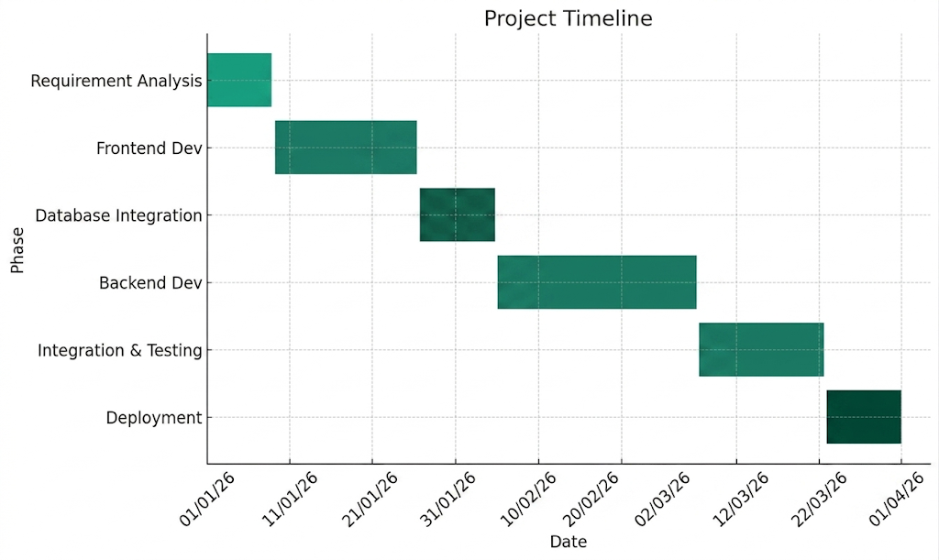
Database Integration
Figure 1: Project Timeline Chart
  - Detailed Module Description

3.4.1 Authentication Module
● Functionality: Enables secure login and access management for users.
● Key Features:
o JWT-Based Authentication: Ensures secure login and session management.
o Secure Access Control: Each user can access only their own financial data.
o Session Handling: Maintains user sessions securely for seamless interaction with the platform.

3.4.2 Data Ingestion & Portfolio Reconstruction Module
● Functionality: Handles automated data collection and portfolio creation.
● Key Features:
o NAV Fetching: Daily NAV (Net Asset Value) data is fetched from public sources and stored.
o CSV Upload Processing: Users can upload transaction files which are parsed and validated.
o Portfolio Reconstruction: System rebuilds complete portfolios from raw transaction data automatically.

3.4.3 Portfolio Analytics Module
● Functionality: Performs advanced financial calculations and performance analysis.
● Key Features:
o Return Calculations: Computes XIRR, CAGR, and total profit/loss.
o Multi-Cashflow Handling: Accurately processes investments made on different dates.
o Real-Time Valuation: Uses latest NAV data to calculate current portfolio value.

3.4.4 Investment Operations Module (SIP, STP, SWP, Redeem)
● Functionality: Simulates and manages real-world mutual fund investment operations.
● Key Features:
o SIP (Systematic Investment Plan): Enables periodic investments for wealth creation.
o STP (Systematic Transfer Plan): Allows gradual transfer between funds to manage risk.
o SWP (Systematic Withdrawal Plan): Supports periodic withdrawals for income generation.
o Redeem Functionality: Enables one-time withdrawal of invested units.

3.4.5 Goal Tracking & Financial Planning Module
● Functionality: Helps users plan and track financial goals.
● Key Features:
o Goal Creation: Users can define targets such as retirement or savings goals.
o Projection Engine: Estimates future value based on current investments.
o Progress Monitoring: Tracks achievement status and deviations from targets.

3.4.6 Dashboard & Visualization Module
● Functionality: Provides visual representation of portfolio data.
● Key Features:
o Interactive Dashboard: Displays portfolio value and performance metrics.
o Charts & Graphs: Shows asset allocation, returns, and trends.
o Real-Time Updates: Reflects changes instantly based on new data.

3.4.7 Alerts & Notification Module
● Functionality: Provides real-time insights and notifications.
● Key Features:
o Performance Alerts: Notifies users about portfolio changes.
o Goal Alerts: Alerts users when goals deviate from expected progress.
o Event Notifications: Provides updates on important financial activities.

3.4.8 Audit & Logging Module
● Functionality: Tracks system activity and ensures transparency.
● Key Features:
o Activity Logging: Records user actions and system events.
o Data Traceability: Maintains logs for debugging and auditing.
o System Monitoring: Helps maintain reliability and performance.

3.5 Project SRS
3.5.1 Use Case Diagram
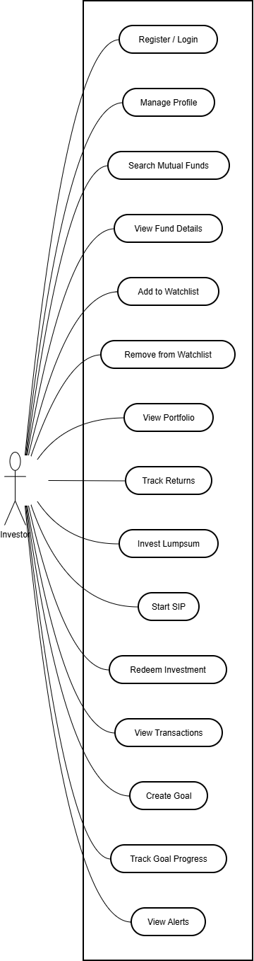
Figure 2: UseCase Diagram

3.5.2 Data Flow Diagram
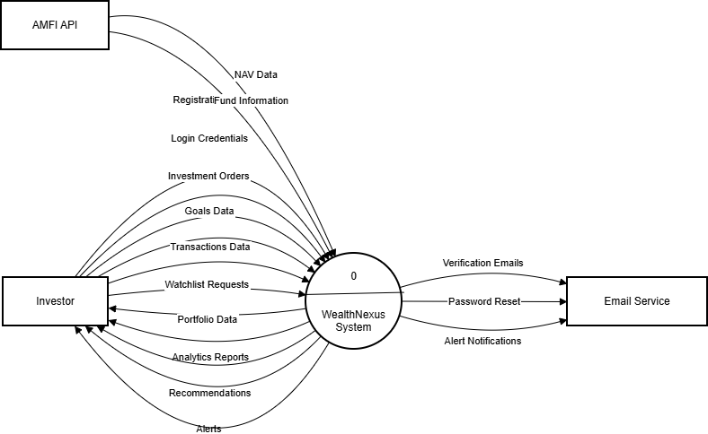
Figure 3.1: Data-Flow Diagram (Level 0)

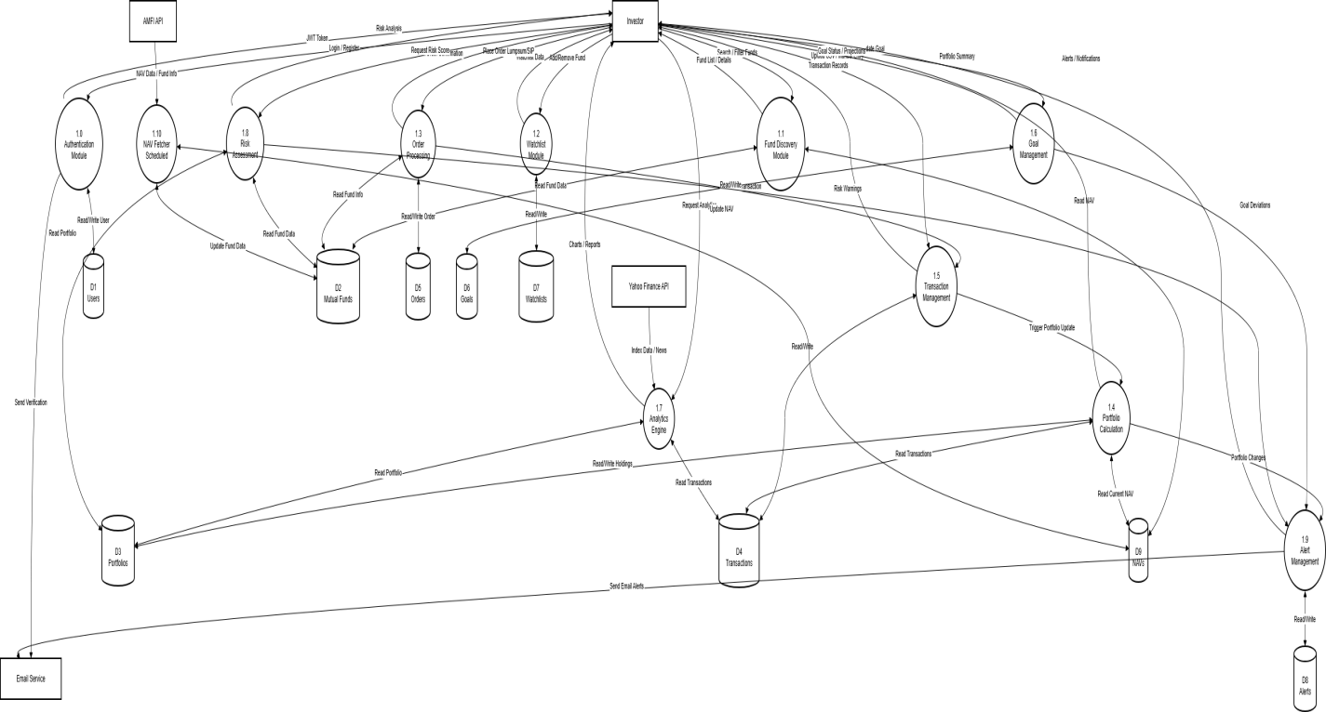
Figure 3.2: Data-Flow Diagram (Level 1)

3.5.3 Class diagram

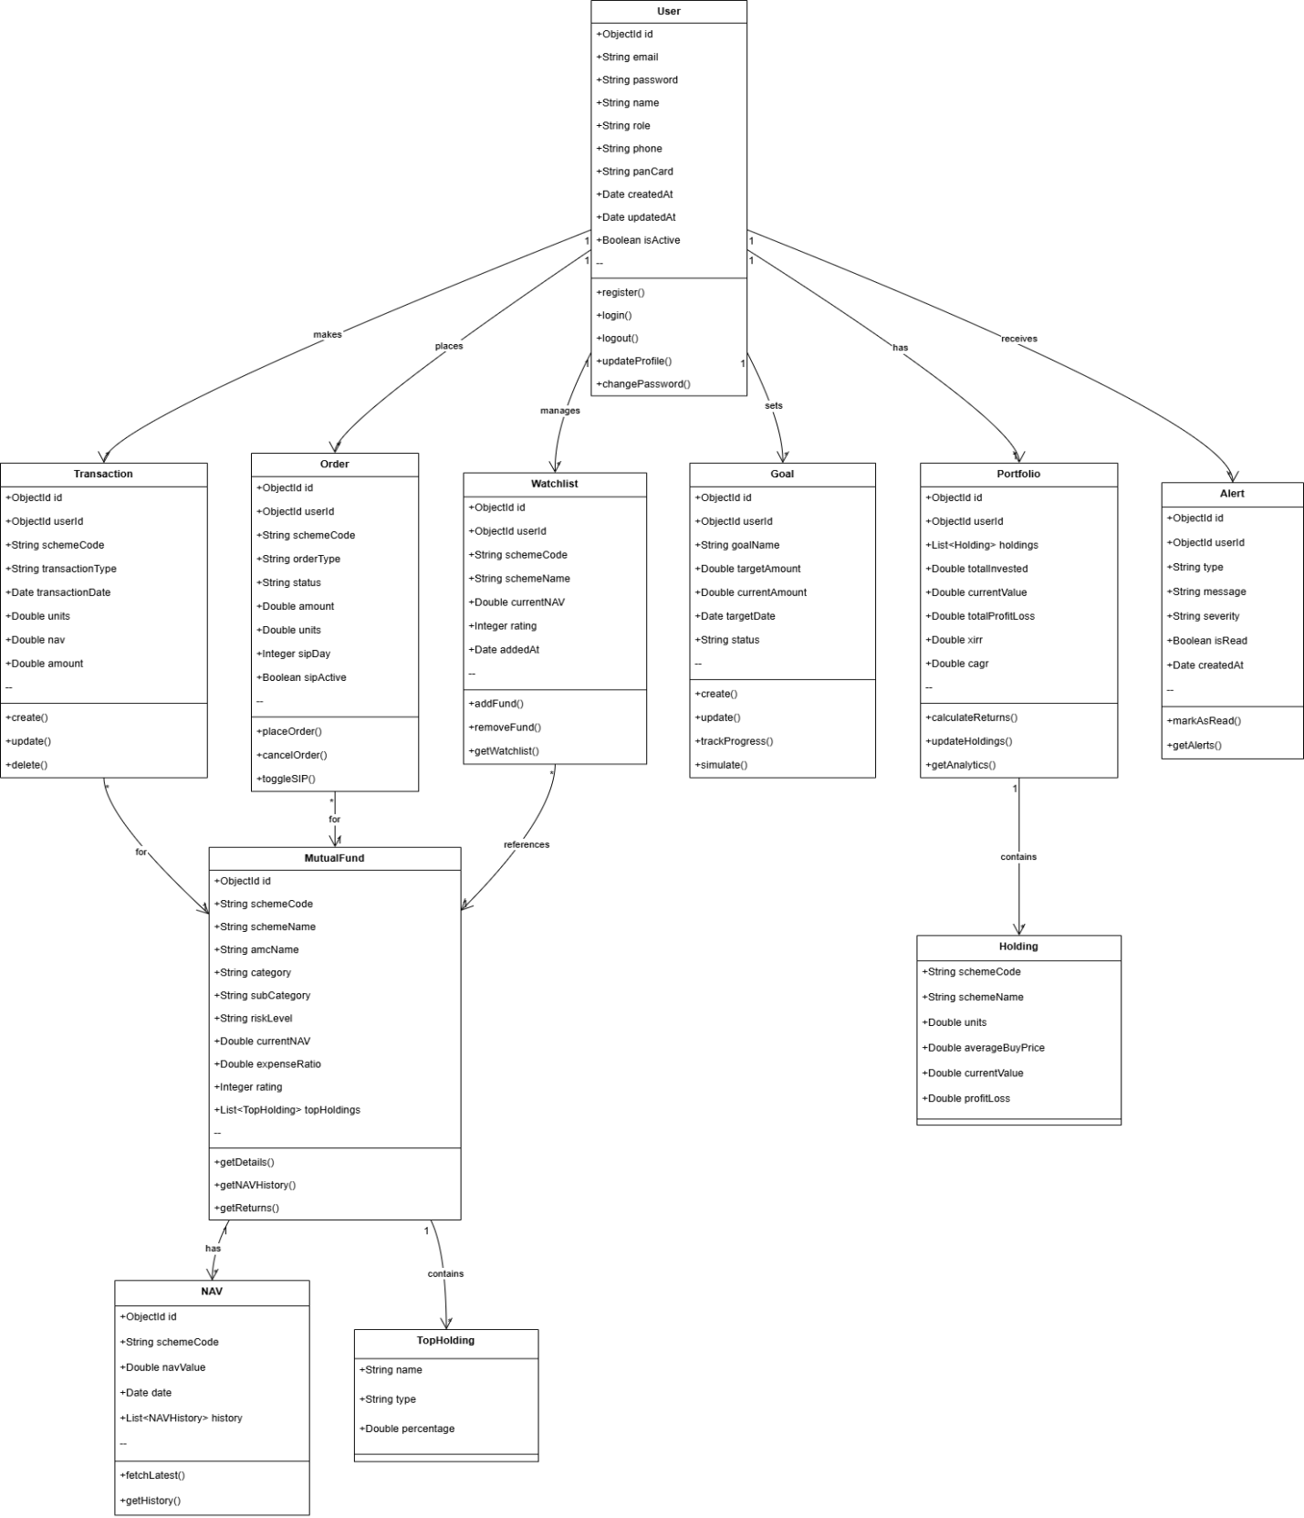
Figure 4: Class Diagram

3.5.4 Entity Relationship Diagram

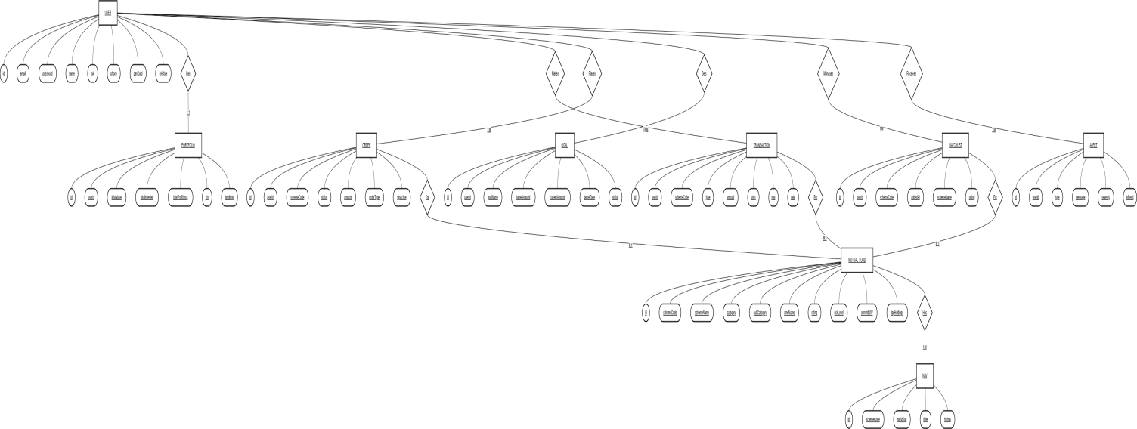
Figure 5: Entity-Relationship Diagram

3.5.5 Sequence Diagram

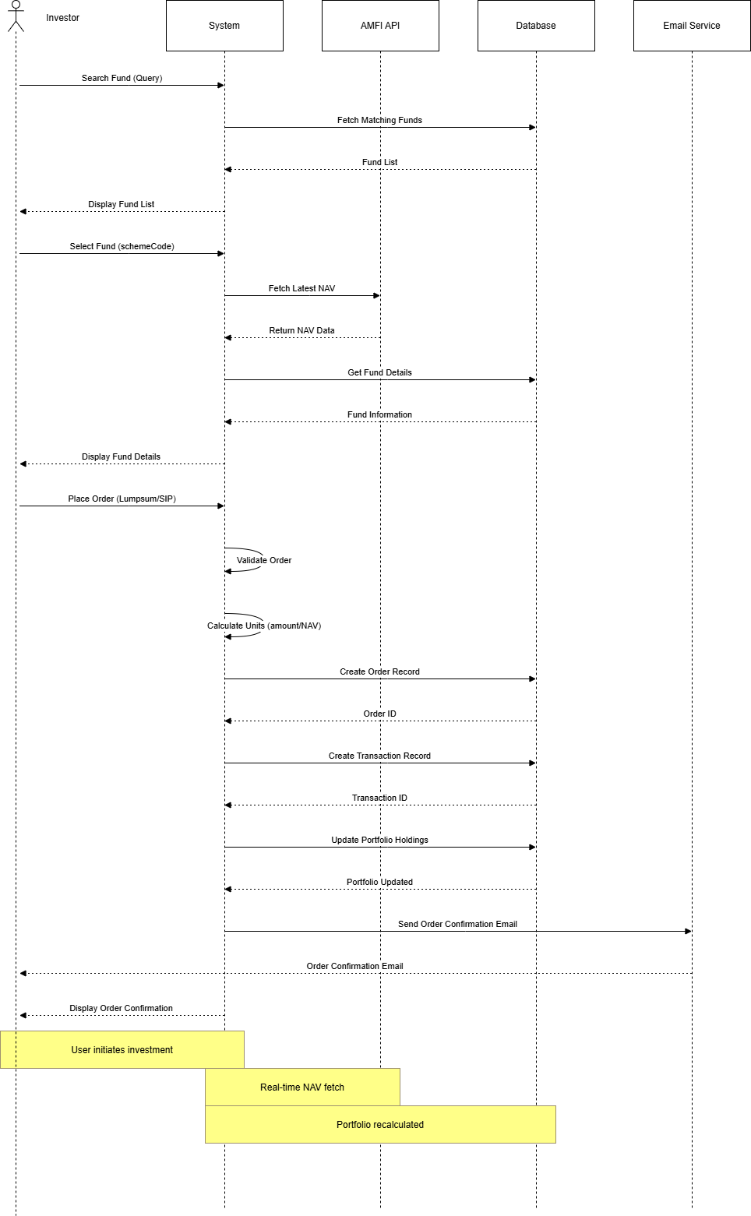
Figure 6: Sequence Diagram

3.5.6 Activity diagram
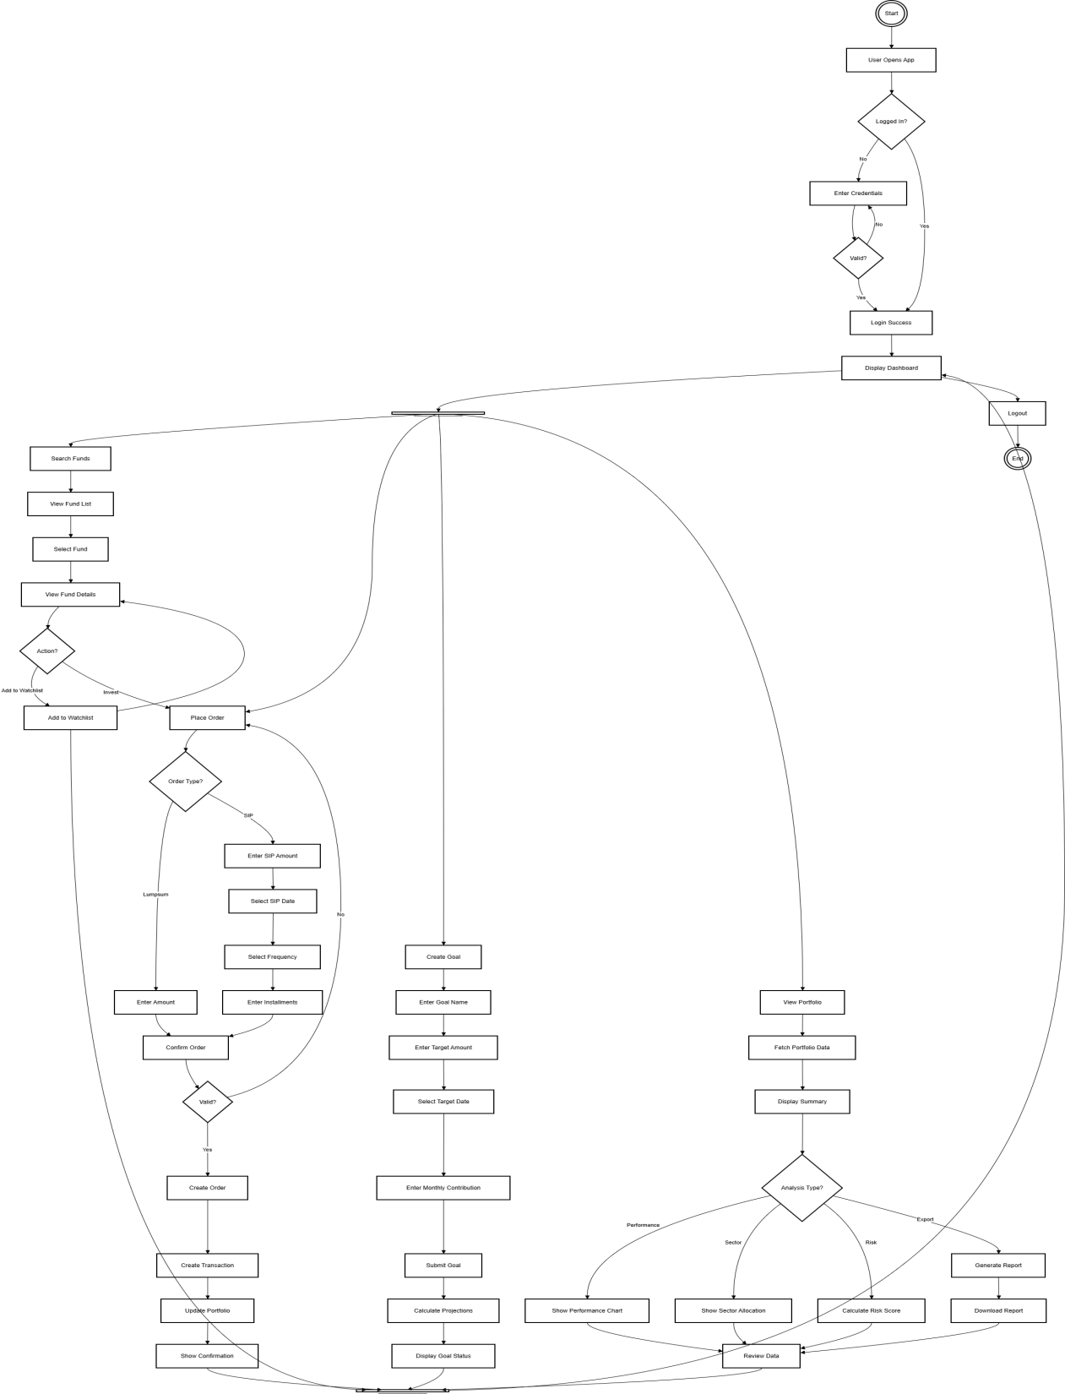
Fig. 7 Activity Diagram

3.6 Data Dictionary

3.6.1. USER Collection
Attribute | Data Type | Constraints | Description
id | ObjectId | PK, Not Null | Unique identifier for the user account.
email | String | Unique, Not Null | Registered email address (used for login).
password | String | Not Null | Encrypted password hash.
name | String | Not Null | Full name of the investor.
role | Enum | Not Null | User role: INVESTOR, ADVISOR, or ADMIN.
phone | String | Optional | Mobile number for alerts and 2FA.
panCard | String | Unique | Permanent Account Number for KYC.
isActive | Boolean | Default: true | Account status (active or suspended).
Table 3: Data Dictionary For User

3.6.2. PORTFOLIO Collection
Attribute | Data Type | Constraints | Description
id | ObjectId | PK, Not Null | Unique portfolio identifier.
userId | ObjectId | FK, Unique | Link to the owner (1:1 Relationship).
totalInvested | Double | Default: 0.0 | Sum of all purchase amounts.
currentValue | Double | Default: 0.0 | Current value based on latest NAV.
totalProfitLoss | Double | Calculated | Current Value - Total Invested.
xirr | Double | Calculated | Extended Internal Rate of Return (Annualized).
Table 4: Data Dictionary For Portfolio

3.6.3. TRANSACTION Collection
Attribute | Data Type | Constraints | Description
id | ObjectId | PK, Not Null | Unique transaction identifier.
userId | ObjectId | FK, Not Null | The investor making the transaction.
schemeCode | String | FK, Not Null | The mutual fund being traded.
type | Enum | Not Null | BUY, SELL, SIP, or DIVIDEND.
amount | Double | Not Null | Total money involved in the transaction.
units | Double | Not Null | Number of mutual fund units purchased/sold.
nav | Double | Not Null | NAV at the time of the transaction.
date | DateTime | Not Null | Timestamp when the transaction occurred.
Table 5: Data Dictionary For Transaction

3.6.4. ORDER Collection
Attribute | Data Type | Constraints | Description
id | ObjectId | PK, Not Null | Unique order identifier.
userId | ObjectId | FK, Not Null | Link to the user placing the order.
schemeCode | String | FK, Not Null | Target mutual fund scheme.
status | Enum | Not Null | PENDING, EXECUTED, CANCELLED, FAILED.
orderType | Enum | Not Null | LUMPSUM or SIP.
amount | Double | Not Null | Target investment amount.
sipFrequency | String | Optional | MONTHLY or QUARTERLY (if SIP).
Table 6: Data Dictionary For Order

3.6.5. MUTUAL_FUND Collection
Attribute | Data Type | Constraints | Description
id | ObjectId | PK, Not Null | Internal system ID.
schemeCode | String | PK, Unique | Official AMFI/Market scheme identifier.
schemeName | String | Not Null | Full name of the mutual fund.
amcName | String | Not Null | Name of the Asset Management Company.
category | String | Not Null | e.g., Equity, Debt, Hybrid, Index.
riskLevel | String | Not Null | e.g., Low, Moderate, High, Very High.
currentNAV | Double | Not Null | Most recent Net Asset Value.
rating | Integer | Range: 1-5 | Performance rating (stars).
Table 7: Data Dictionary For Mutual Fund

3.6.6. NAV Collection
Attribute | Data Type | Constraints | Description
id | ObjectId | PK, Not Null | Unique history entry ID.
schemeCode | String | FK, Not Null | Link to the Mutual Fund scheme.
navValue | Double | Not Null | The NAV price on a specific date.
date | Date | Not Null | The specific market date for this NAV record.
Table 8: Data Dictionary For NAV

3.6.7.GOAL Collection
Attribute | Data Type | Constraints | Description
id | ObjectId | PK, Not Null | Unique identifier for the financial goal.
userId | ObjectId | FK, Not Null | Link to the User (1:N Relationship).
goalName | String | Not Null | Name (e.g., "Retirement", "New Car").
targetAmount | Double | Not Null | The final corpus amount required.
currentAmount | Double | Default: 0.0 | Sum of funds currently allocated to this goal.
targetDate | Date | Not Null | Expected achievement date.
status | Enum | Not Null | ON_TRACK, OFF_TRACK, ACHIEVED.
Table 9: Data Dictionary For Goal

3.6.8.WATCHLIST Collection
Attribute | Data Type | Constraints | Description
id | ObjectId | PK, Not Null | Unique identifier for the watchlist entry.
userId | ObjectId | FK, Not Null | Link to the User monitoring the fund.
schemeCode | String | FK, Not Null | Link to the Mutual Fund being watched.
schemeName | String | Not Null | Denormalized name for quick display.
rating | Integer | Range: 1-5 | Current rating at the time of tracking.
Table 10: Data Dictionary For WatchList

Chapter 4: Implementation and Testing
4.1 User Interface Snapshots
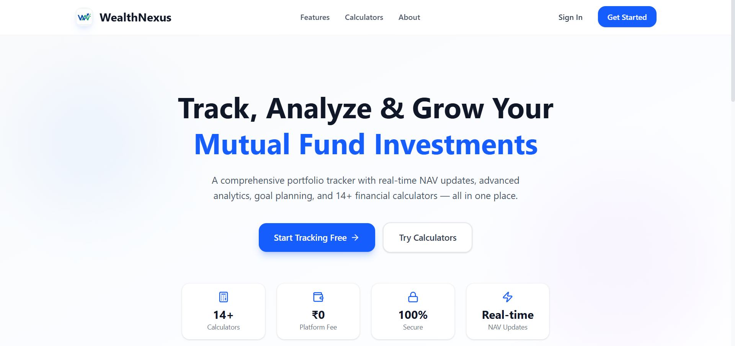
Fig. 8.1: UI - Home Page

Fig. 8.2: UI – Institute Registration Page

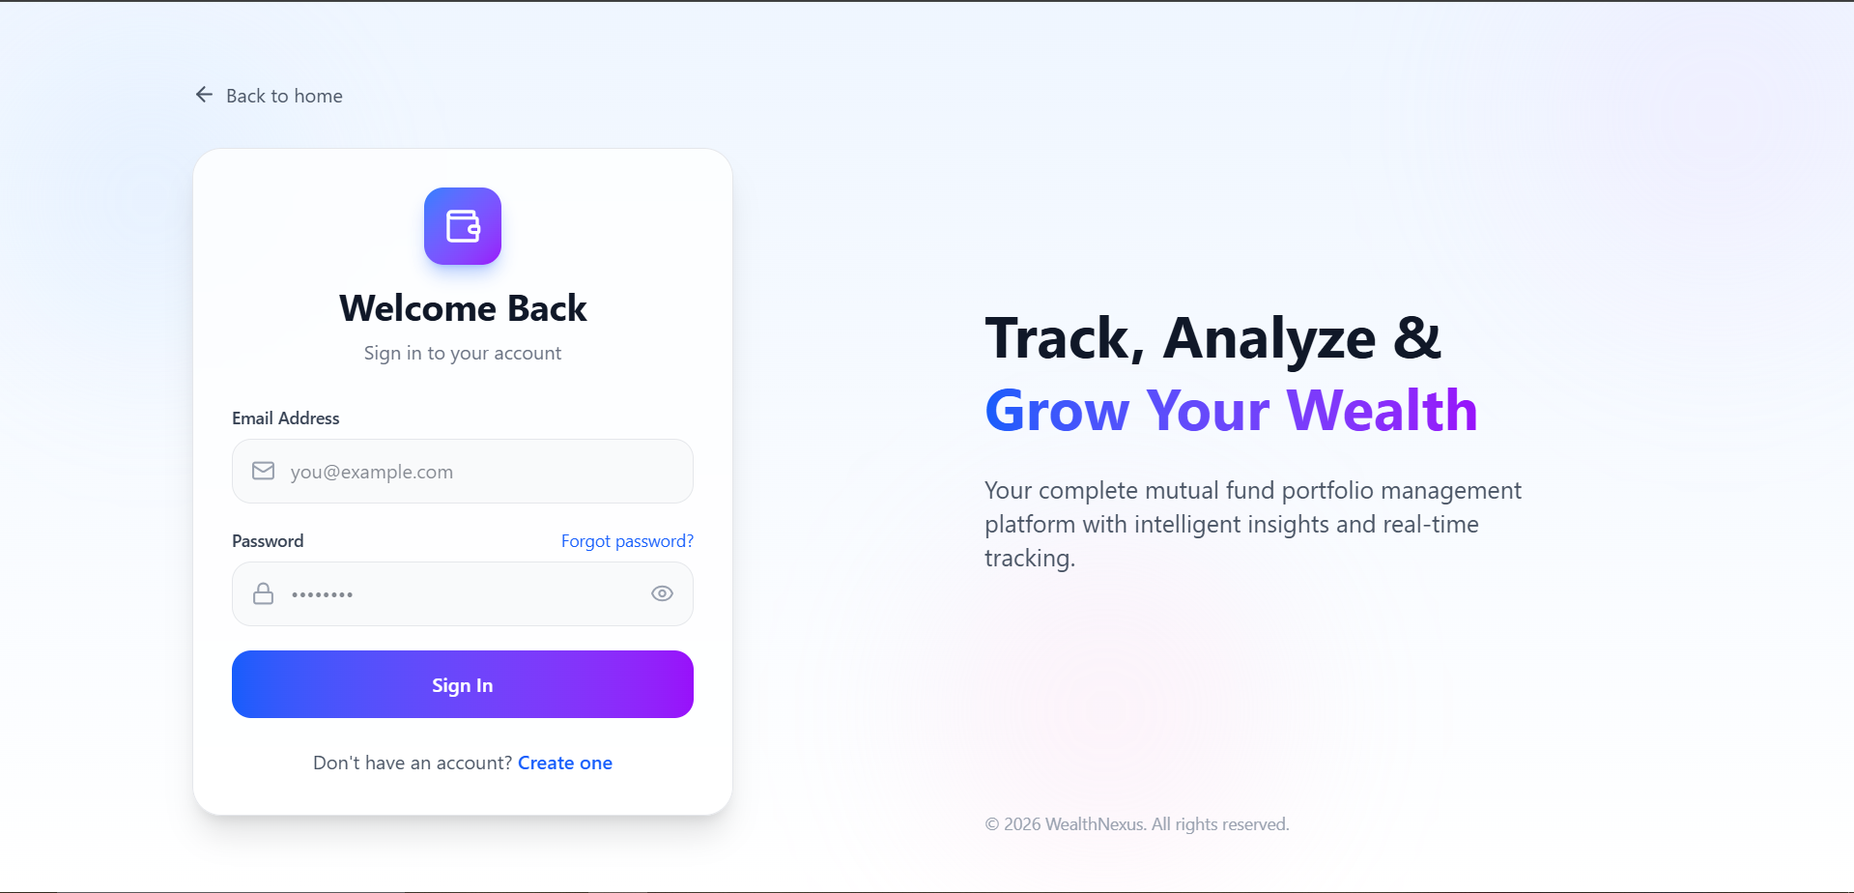
Fig. 8.3: UI – Login Page
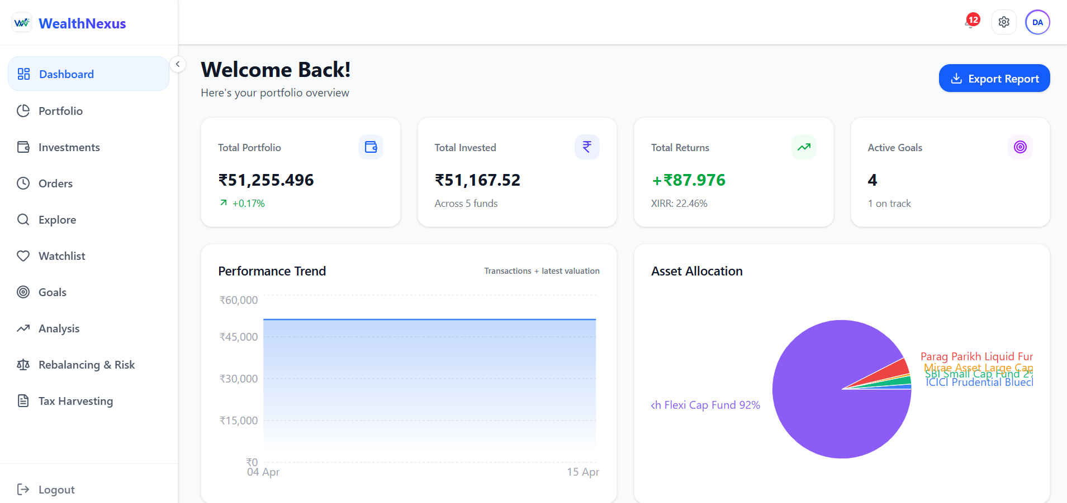
Fig. 8.4: UI – Software Dashboard
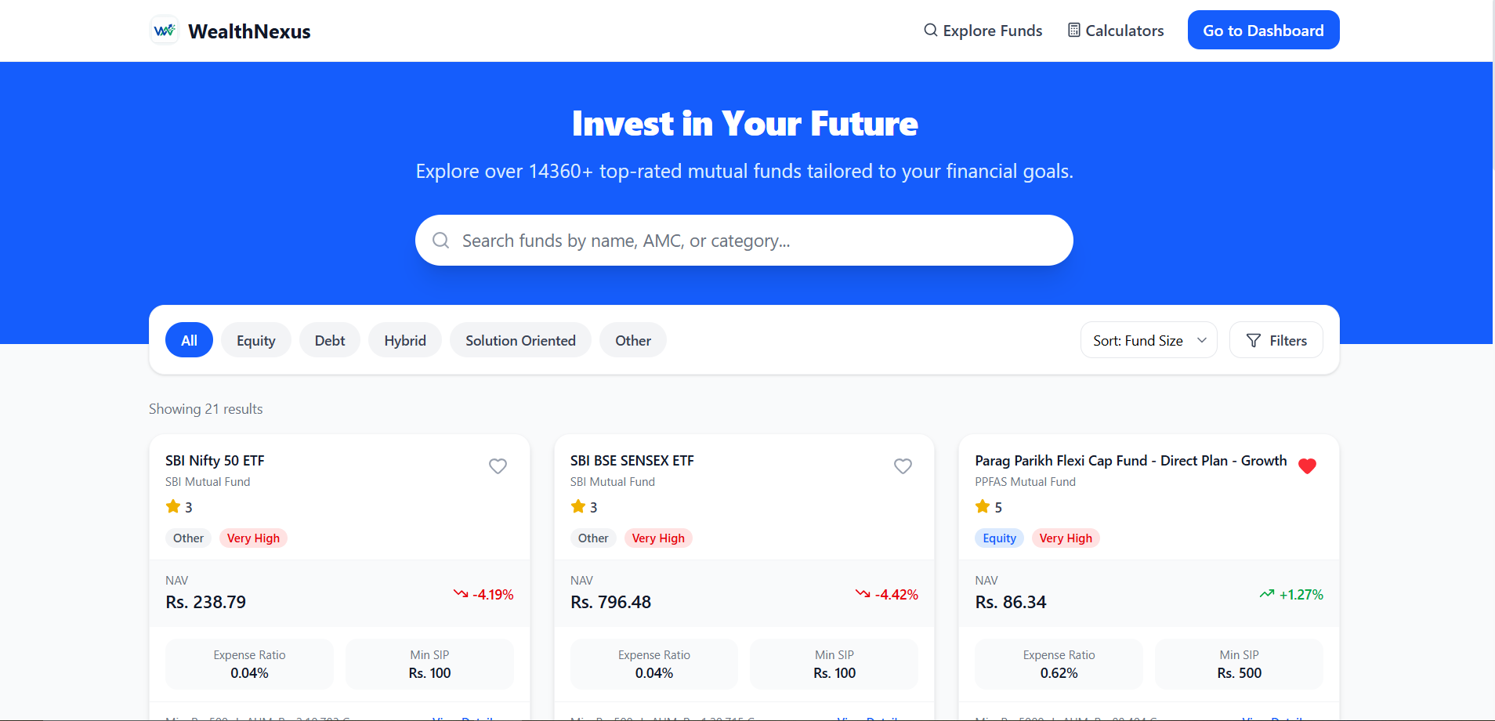

Fig.8.5: UI – Registered User Dashboard
4.2 Result Analysis

1.The Wealth-Nexus system was successfully implemented and tested using real-world mutual fund transaction data. The data ingestion module accurately processed CSV files and reconstructed complete portfolios without errors. Automated NAV updates ensured that portfolio values remained current and reliable.
2.The portfolio analytics module effectively computed financial metrics such as XIRR, CAGR, and profit/loss. XIRR proved especially useful in handling multiple cash flows occurring at different time intervals, providing a realistic measure of investment performance . The results were consistent with expected financial calculations.
3.The investment operations module, including SIP, STP, SWP, and redemption functionalities, successfully simulated real-world mutual fund activities. The system handled periodic investments, transfers, and withdrawals efficiently. This demonstrated the platform’s capability to model actual investor behavior.
4.The goal tracking and dashboard modules provided clear visualization of portfolio performance and financial progress. Users were able to monitor their investment growth and goal achievement effectively. Graphical representations improved understanding and supported better decision-making.
5.The system maintained high performance and reliability during testing. Features such as alerts, logging, and real-time updates functioned correctly under different scenarios. Overall, Wealth-Nexus proved to be a scalable and efficient solution for portfolio management and financial analysis.

4.3 Testing using Use Cases

4.3.1 Authentication Module
Sr No | Test Scenario | Input Condition | Expected Result | Status
1 | Empty Fields | User clicks login without email/password | Validation error displayed, form not submitted | Valid
2 | Invalid Credentials | Wrong email/password entered | Error message shown | Valid
3 | Valid Login | Correct email/password | User redirected to dashboard | Valid
4 | Invalid Input | Special characters entered | Input rejected securely | Valid
Table 10: Test Cases For Authentication
4.3.2 CSV Upload & Data Ingestion
Sr No | Test Scenario | Input Condition | Expected Result | Status
1 | Empty CSV Upload | Blank file uploaded | Error message shown | Valid
2 | Invalid Format | Wrong CSV structure | File rejected | Valid
3 | Valid CSV Upload | Proper transaction file | Data parsed successfully | Valid
4 | Large File Upload | Large dataset | System processes without crash | Valid
Table 11: Test Cases For CSV Upload
4.3.3 Portfolio Analytics
Sr No | Test Scenario | Input Condition | Expected Result | Status
1 | No Transactions | Empty portfolio | Values shown as zero | Valid
2 | XIRR Calculation | Multiple SIP entries | Correct XIRR calculated | Valid
3 | Invalid Data | Incorrect values | Error handled properly | Valid
4 | NAV Update | Latest NAV available | Portfolio updated correctly | Valid
Table 12: Test Cases For Portfolio

4.3.4 Investment Operations (SIP, STP, SWP, Redeem)
Sr No | Test Scenario | Input Condition | Expected Result | Status
1 | SIP Execution | Monthly investment | Units allocated correctly | Valid
2 | STP Transfer | Fund transfer | Units updated correctly | Valid
3 | SWP Withdrawal | Periodic withdrawal | Units reduced correctly | Valid
4 | Redeem | Full withdrawal | Portfolio updated | Valid
Table 13: Test Cases For Investment Operation
4.3.5 Goal Tracking Module
Sr No | Test Scenario | Input Condition | Expected Result | Status
1 | Create Goal | Valid input | Goal created successfully | Valid
2 | Invalid Goal | Negative value | Error message shown | Valid
3 | Goal Progress | Portfolio growth | Progress updated | Valid
4 | Goal Deviation | Low returns | Alert triggered | Valid
Table 14: Test Cases For Goal

4.3.6 Dashboard & Visualization
Sr No | Test Scenario | Input Condition | Expected Result | Status
1 | Dashboard Load | After login | Dashboard loads | Valid
2 | Chart Display | Data available | Graphs shown correctly | Valid
3 | Empty State | No data | Message displayed | Valid
4 | Real-Time Update | NAV updated | UI updates instantly | Valid
Table 15: Test Cases For Dashboard
4.3.7 Alerts & Notifications
Sr No | Test Scenario | Input Condition | Expected Result | Status
1 | Goal Alert | Goal deviation | Notification generated | Valid
2 | Performance Alert | Portfolio drop | Alert triggered | Valid
3 | Mark as Read | User clicks alert | Status updated | Valid
Table 16: Test Cases For Alert

Chapter 5: Conclusion and Future Work
5.1 Conclusion
The Wealth-Nexus project was undertaken with the primary objective of simplifying mutual fund portfolio management and enabling accurate, data-driven financial decision-making. The platform successfully addresses challenges such as fragmented investment data, manual tracking, and lack of actionable insights by providing a centralized and intelligent portfolio analytics system.
The system has been implemented using a robust architecture with React.js for the frontend, Spring Boot for backend processing, and MongoDB with Redis caching for efficient data handling. Key achievements of the implementation include:
● Accurate Portfolio Reconstruction: The system processes user-uploaded transaction data and reconstructs complete portfolios with high accuracy.
● Advanced Financial Analytics: Metrics such as XIRR, CAGR, and profit/loss are computed efficiently, even with multiple and irregular cash flows.
● Investment Operations Support: The platform successfully simulates real-world mutual fund operations such as SIP, STP, SWP, and redemption, reflecting realistic investment behavior.
● Interactive Dashboard: Users are provided with intuitive visualizations for portfolio performance, asset allocation, and financial progress.
● Real-Time Updates & Alerts: Automated NAV updates and alert mechanisms ensure users stay informed about portfolio changes and goal deviations.
In comparison to traditional investment tracking methods, Wealth-Nexus offers a more automated, scalable, and insight-driven approach. By integrating data processing, financial computation, and visualization, the system enhances transparency and empowers investors to make informed financial decisions efficiently.

5.2 Future Work
While Wealth-Nexus currently provides a comprehensive solution for mutual fund portfolio management and analytics, several opportunities exist for further enhancement and scalability:
● Multi-Asset Expansion: The platform can be extended beyond mutual funds to include other asset classes such as stocks, ETFs, and bonds, enabling users to manage their entire investment portfolio in one place.
● Real-Time Data Integration: Future versions can integrate official APIs from financial institutions and AMCs to fetch real-time transaction and portfolio data using PAN-based authentication, eliminating the need for manual CSV uploads.
● Mobile Application Development: Currently implemented as a web-based platform, future work may include developing a mobile application to provide users with seamless access, real-time notifications, and improved user experience on handheld devices.
● AI-Based Financial Insights: The system can be enhanced with AI/ML models to provide predictive insights, personalized investment suggestions, and risk analysis based on user behavior and market trends.

Chapter 6: References
[1] M. M. J. Khiloshiya, “A Study of Wealth Management and Financial Planning”, 2023. Available: https://gscen.shikshamandal.org/wp-content/uploads/2023/08/21-Mehul-Khiloshiya.pdf.
[2] K. Kaur, “To Study the Growth of Mutual Funds Regarding Salaried Individuals”, 2021. Available: https://www.drnishikantjha.com/papersCollection/TO%20STUDY%20THE%20GROWTH%20OF%20MUTUAL%20FUNDS%20REGARDING%20SALARIED%20INDIVIDUALS.pdf.
[3] “Systematic Investment Plan (SIP)”, Wikipedia. [Online]. Available: https://en.wikipedia.org/wiki/Systematic_investment_plan.
[4] MongoDB, Inc., “Introduction to MongoDB”, MongoDB Manual. [Online]. Available: https://www.mongodb.com/docs/manual/.
[5] Vercel, “Introduction”, Next.js Documentation. [Online]. Available: https://nextjs.org/docs

